**Experiment No. 10**

**Aim:** Introduction to Shell programming: .sh files, simple shell scripts, execution of shell scripts, Arithmetic operations.

1. **How to check your shell:**

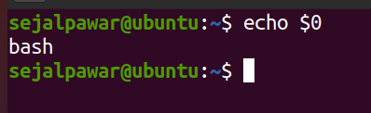

1. **Creating first script using touch command:**

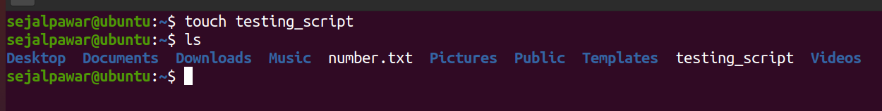



* **Writing script:**

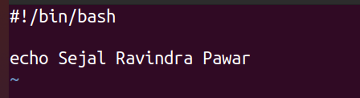

* **Running script:**

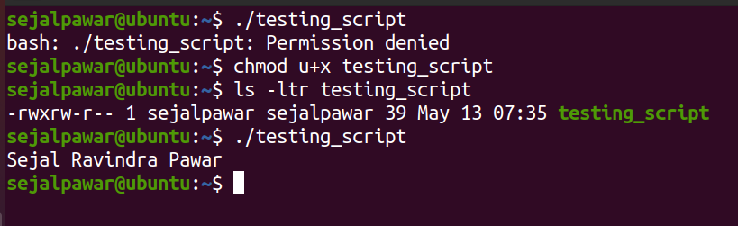

1. **Removing script:**

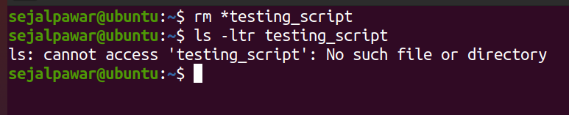

1. **Creating script using vi and executing it:**

* **Creating script:**

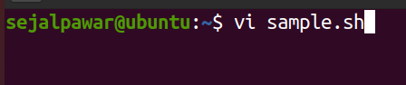

* **Writing into script:**

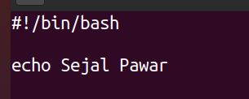

* **Executing script:**

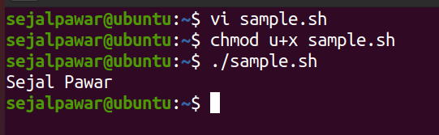

1. **Input from user:**

* **Creating script:**



* **Writing into script:**

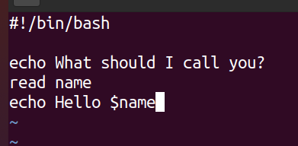

* **Executing script:**

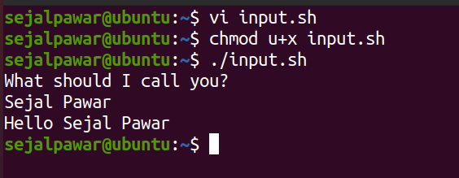

1. **If-else:**

* **Creating script:**

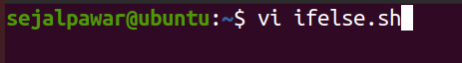

* **Writing into script:**

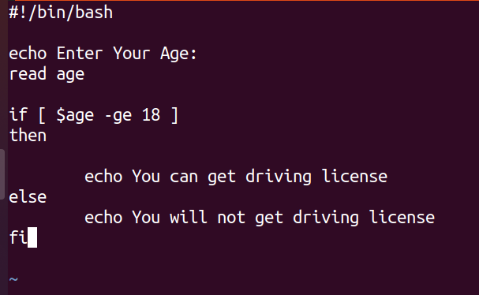

* **Executing script:**

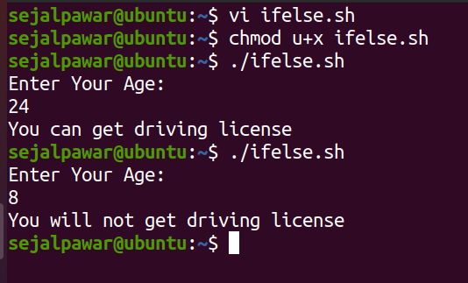

1. **Case Condition:**

* **Creating script:**

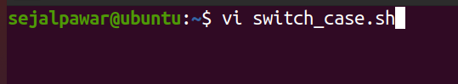

* **Writing into script:**

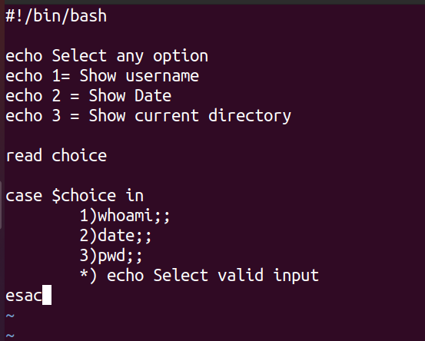

* **Executing script:**

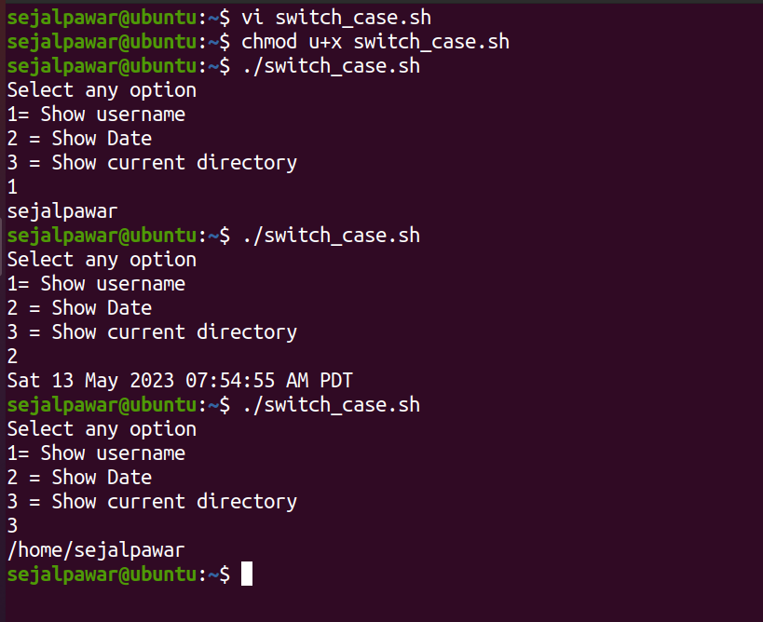

1. **For Loop:**

* **Creating script:**

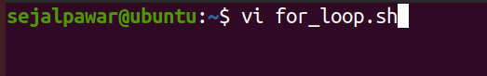

* **Writing into script:**

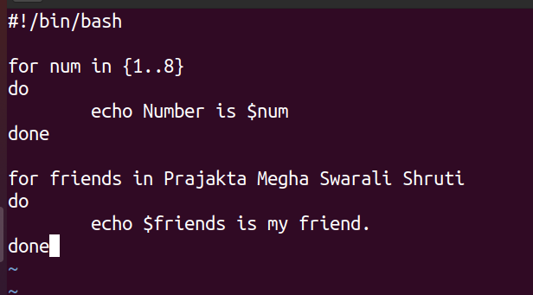

* **Executing script:**

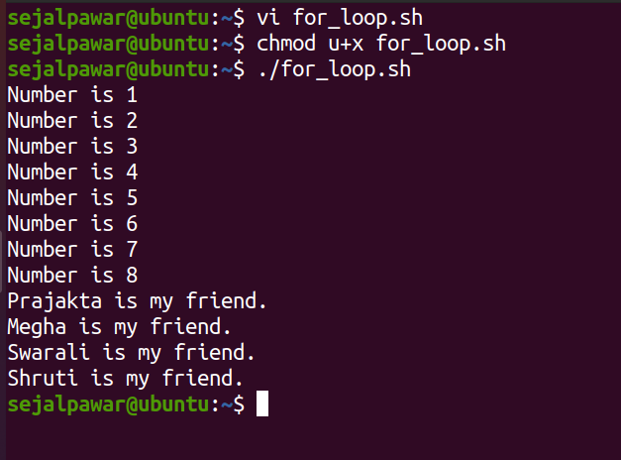

|  |  |  |  |
| --- | --- | --- | --- |
| **Practical Performance**  **(4)** | **Writeup & Oral**  **(4)** | **Attendance**  **(2)** | **Total**  **(10)** |
|  |  |  |  |